**Module – 1**

1. **What is software testing?**

**Software testing is a process used to identify the Correctness, Completeness and Quality of developed computer software.**

* **Testing Activities:**

**Planning and control.**

**Choosing test conditions.**

**Designing test case.**

**Checking results.**

**Evaluation completion criteria.**

**Reporting on the testing process and system under test.**

**Finalizing or closure.**

**Testing also includes reviewing of documents and static analysis**

* **Teat objectives:**

**Finding defects.**

**Gaining confidence in and providing information about the level of Quality.**

**Preventing defects.**

**Preventing defect both dynamic and static.**

1. **What is SDLC?**

**SDLC is structure imposed on the development of a software product that defines the process for planning,implemention,testing,documentation,deployment, and ongoing maintenance and support.**

1. **Write SDLC phases with basic introduction?**

**SDLC phases and Basic introduction:**

1. **Requirements collection/gathering**

**Establish customer needs**

1. **Analysis**

**Model and specify the requirements**

1. **Design**

**Model and specify a solution**

1. **Implementaion**

**Construct a solution in software**

1. **Testing**

**Validate the solution against the requirements**

1. **Maintenance**

**Repair defects and adapt the solution to the new requirements**

1. **What is SRS**

**Ans:**

**A software requirements specification(SRS) is a complete description of the behavior the system to be developed.**

**It includes a set of use cases that describe all of the interaction that the users will have with the software.**

**Use cases are also known as functional requirements. In addition to use cases, the SRS also contain non functional (or supplementary) requirements.**

1. **What is agile methodology?**

**Ans:**

**Agile SDLC model is a combination of iterative and incremental process model with focus on process adaptability and customer satisfaction by rapid delivery of working software product.**

**Agile methods break the product into small incremental builds.**

**These builds are provided in iterations.**

**Each iteration typically lasts from about one to three weeks.**

1. **What is OOPS?**

* **Identifying objects and assigning responsibilities to these objects.**
* **Objects communicate to other objects by sending messages.**
* **Messages are received by the methods of an object.**
* **An object is like a black box.**
* **The internal detailsare hidden.**

1. **Write basic concepts of oops**

* **Objects**
* **Class**
* **Encapsulation**
* **Inheritance**
* **Polymorphism**
* **Abstraction**

1. **What is object**

* **Tangible things**
* **Roles**
* **Incidents**
* **Interaction**
* **Specification**

1. **What is class**

**When you define a class, you define a blueprint for an object. This doesn’t actually data, but it does define what the class name means, that is , what an objects of the class will consist of and what operation can be performed on such an object. A class represents an abstraction of the objects and abstracts the properties and behavior of that object.**

1. **What is encapsulation**

* **Encapsulation is the practice of including in an object everything it needs hidden from other objects. The internal state is usually not accessible by other objects.**
* **Encapsulate in plain English means to enclose or be enclosed in or if in a copsule. In java, a class in the capsule.**

1. **What is inheritance**

* **Inheritance means that one class inherits the characteristics of another class. This is also called a “is a” relationship.**

1. **What is polymorphism**

* **Polymorphism means “ having many forms” .**
* **It allows differ objects to respond to the same message in different ways. The response specific to the type of the objects.**
* **The most important aspect of an objects its behavior. A behavior is initiated by sending message to the object.**

1. **Explain phases of the waterfall model**

**The classical software lifecycle n the software development as a by-step “waterfall” between the various development phases**

* **Reguirements collection**
* **Analysis**
* **Design**
* **Implementation**
* **Testing**
* **Maintenance**

1. **Explain phases of spiral model**

**Spiral model is very widely used in the software industry as it is in synchwith the natural development process of any product i.e. learning with maturity and also involves minimum risk for the customer as well as the development firms.following are the typical uses of spiral model:**

* **Planning = determination of objectives, alternatives and constraints**
* **Risk analysis = analysis of alternatives and identification/resolution of risk**
* **Customer evaluation = assessment of the results of engineering**
* **Engineering = development of the “next level” product**

1. **Explain working methodology of agile model and also write pros and cons.**

* **Individual interation**
* **Working software**
* **Coustmer collobration**
* **Responding to change**

**16.Draw Use case on online book shopping**

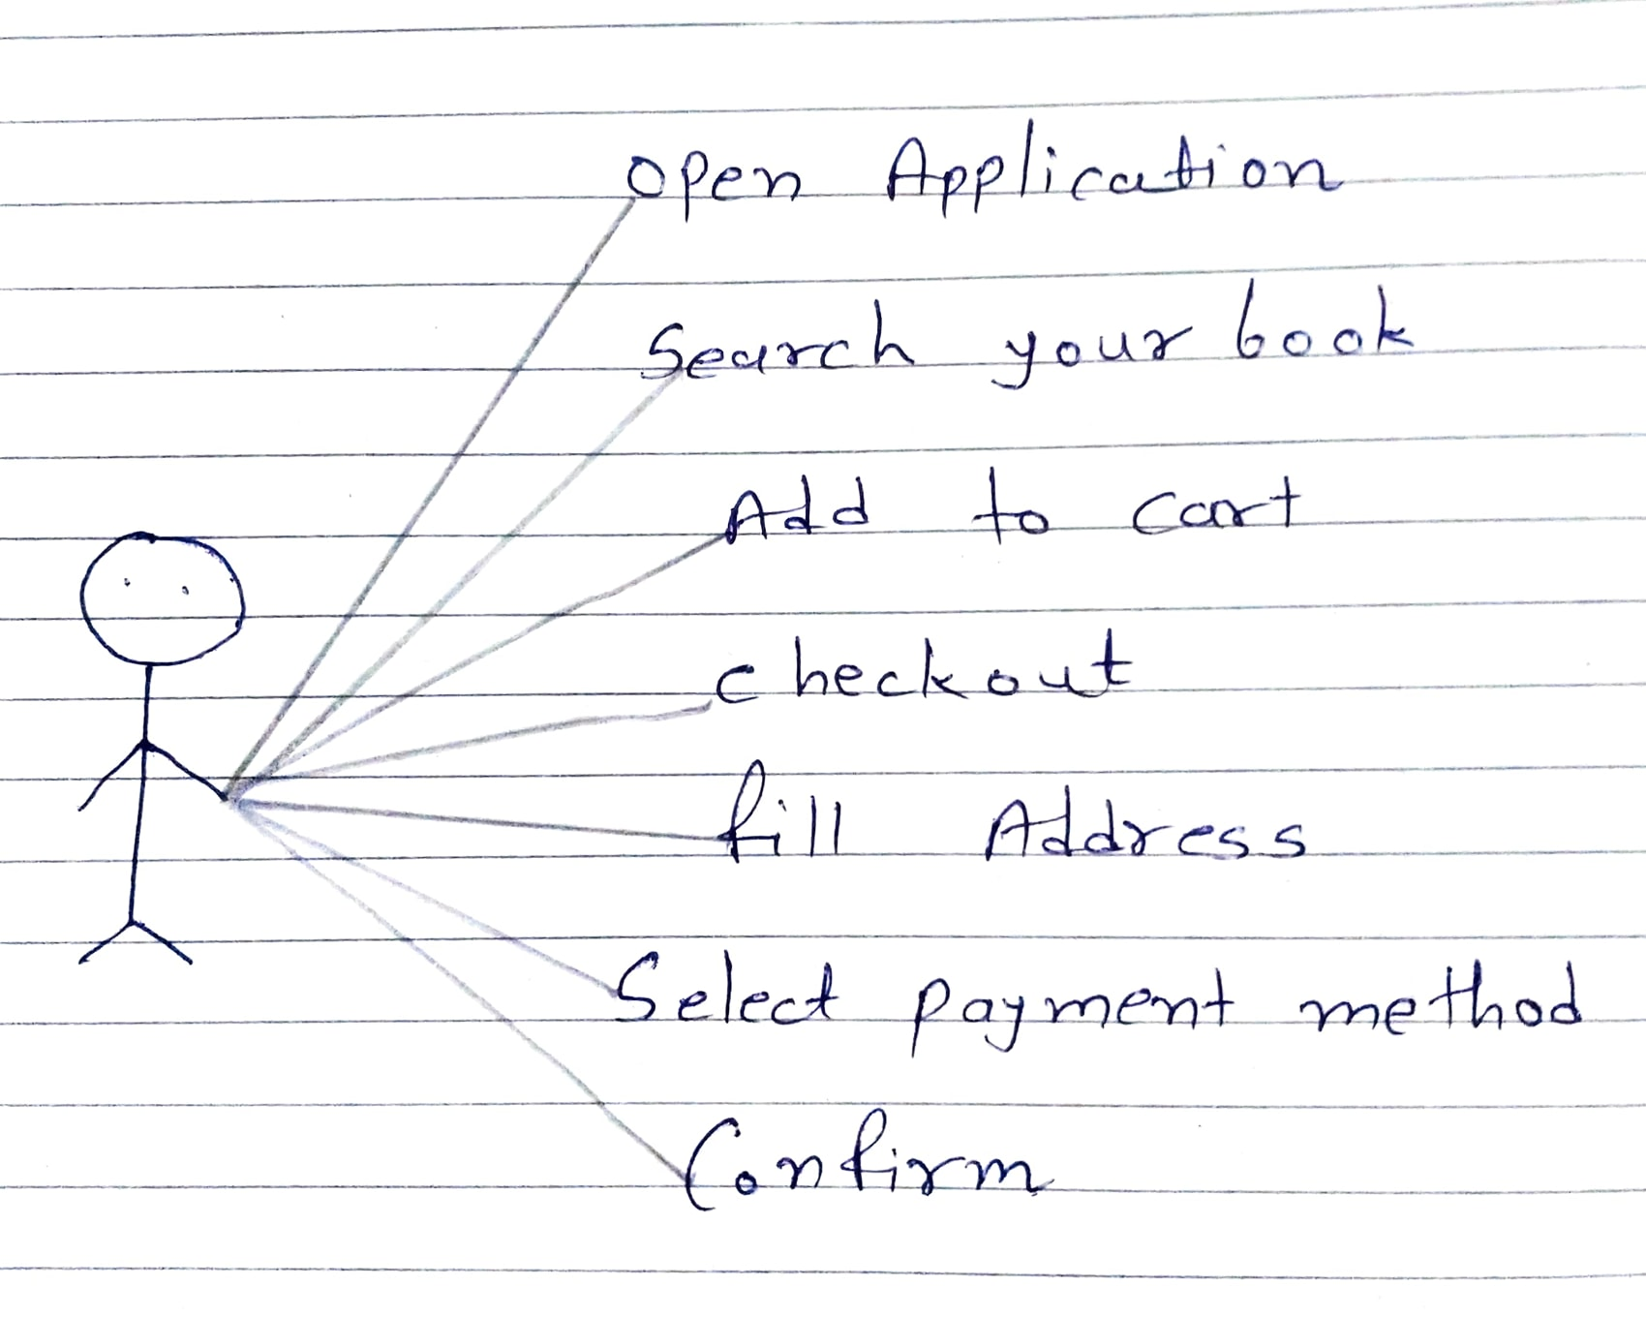

**17.Draw use case on online bill payment system (paytm)  
 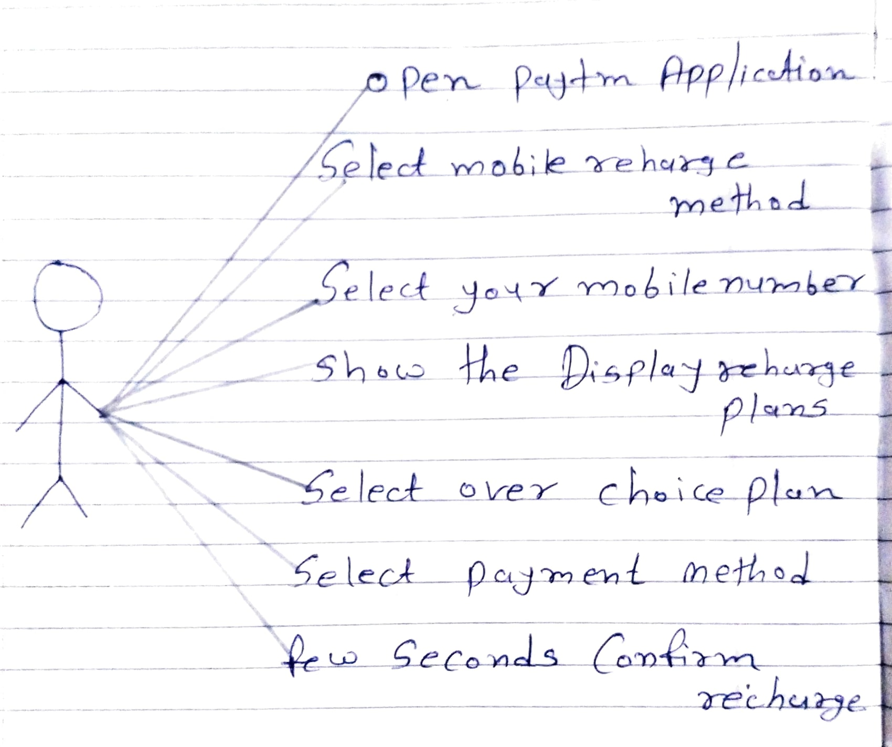**

**18.Draw use case on online shopping product using COD**

**19.Draw use case on online shopping product using payment gateway**

